Top 5 grossing Android games of all time

Download and revenue data spans Jan 2012 to March 2016

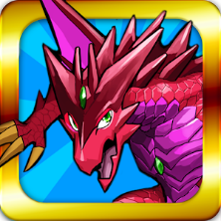
Puzzle & Dragons
Google play release date: September 2012
Company: GungHo Online
Country of Headquarters: Japan
Game link: https://play.google.com/store/apps/details?id=jp.gungho.padEN&hl=en_GB
Revenue

Genre:
Game summary:
Notes:

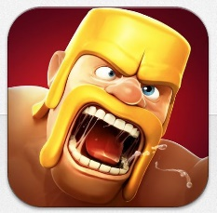
Clash of clans
Google play release date: September 2013
Company: Supercell
Country of Headquarters: Finland
Game link: https://play.google.com/store/apps/details?id=com.supercell.clashofclans&hl=en_GB

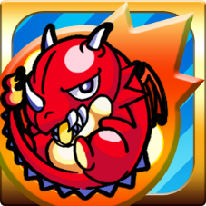
Monster strike
Google play release date: December 2013
Company: Mixi
Country of Headquarters: Japan
Game link: https://play.google.com/store/apps/details?id=jp.co.mixi.monsterstrikeUS&hl=en_GB

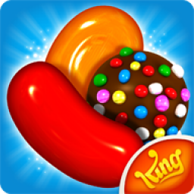
Candy Crush Saga
Google play release date: November 2012
Company: Activision Blizzard
Country of Headquarters: United States
Game link: https://play.google.com/store/apps/details?id=com.king.candycrushsaga&hl=en_GB

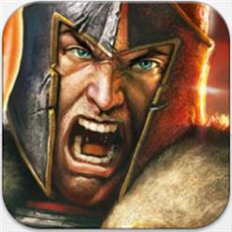
Game of War – Fire Age
Google play release date: March 2014
Company: Machine Zone
Country of Headquarters: United States
Game link: https://play.google.com/store/apps/details?id=com.machinezone.gow&hl=en_GB

Of the games discussed above; Clash of Clans and Candy Crush Saga are still within the top ten games for Q1 2016 based on monthly active users. Based on this information

References

Bibliography
Remove in line citations if they aren’t used
Puzzle & dragons – Android Apps on Google play (2016) Available at: https://play.google.com/store/apps/details?id=jp.gungho.padEN&hl=en_GB (Accessed: 12 November 2016). (Puzzle & dragons – Android Apps on Google play, 2016)
Clash of Clans – Android Apps on Google play (2016) Available at: https://play.google.com/store/apps/details?id=com.supercell.clashofclans&hl=en_GB (Accessed: 12 November 2016). (Clash of Clans – Android Apps on Google play, 2016)
Monster strike – Android Apps on Google play (2016) Available at: https://play.google.com/store/apps/details?id=jp.co.mixi.monsterstrikeUS&hl=en_GB (Accessed: 12 November 2016). (Monster strike – Android Apps on Google play, 2016)
Candy Crush saga – Android Apps on Google play (2016) Available at: https://play.google.com/store/apps/details?id=com.king.candycrushsaga&hl=en_GB (Accessed: 12 November 2016). (Candy Crush saga – Android Apps on Google play, 2016)
Game of war - fire age – Android Apps on Google play (2016) Available at: https://play.google.com/store/apps/details?id=com.machinezone.gow&hl=en_GB (Accessed: 12 November 2016).

